Technical Section

1. Definitions and Core Equations

Bagging (Bootstrap Aggregating)
f^bag(x)=1B∑b=1Bf^b(x)\hat{f}_{bag}(x) = \frac{1}{B} \sum_{b=1}^{B} \hat{f}_b(x)f^​bag​(x)=B1​b=1∑B​f^​b​(x)
Each learner f^b\hat{f}_bf^​b​ is trained on a bootstrap sample of the data (Breiman, 1996).
This method reduces variance by averaging results from multiple base learners.

Boosting
Fm(x)=Fm−1(x)+αmhm(x)F_m(x) = F_{m-1}(x) + \alpha_m h_m(x)Fm​(x)=Fm−1​(x)+αm​hm​(x)
Each weak learner hm(x)h_m(x)hm​(x) corrects the errors of the previous one, effectively reducing bias (Freund & Schapire, 1997).
Modern implementations like XGBoost and Gradient Boosting follow this principle (Chen & Guestrin, 2016).

Stacking
y^=g(h1(x),h2(x),…,hK(x))\hat{y} = g(h_1(x), h_2(x), \ldots, h_K(x))y^​=g(h1​(x),h2​(x),…,hK​(x))
Stacking combines outputs from multiple base models via a meta-learner ggg (Wolpert, 1992).
This technique balances both bias and variance by blending heterogeneous algorithms.

2. Workflow Summary
Data → Train multiple models → Combine predictions → Meta-model → Final output
This process integrates diverse perspectives and yields robust generalization across datasets (Zhou, 2012).
3. Example Implementation in Python (In Jupyter Notebook)
This implementation follows principles outlined by Zhou (2012) in Ensemble Methods: Foundations and Algorithms.

4. Evaluation Metrics
Performance is typically assessed using metrics such as accuracy, ROC-AUC, or RMSE, validated through cross-validation to ensure the model generalizes effectively (Kuhn & Johnson, 2013).

5. Expected Outcomes
- Bagging: Reduces variance by aggregating results from multiple models.
- Boosting: Reduces bias through iterative error correction.
- Stacking: Achieves a balance between bias and variance for superior generalization (Zhang & Ma, 2012).

📊 Comparative Table — Ensemble Techniques Overview
Technique | Core Idea | Strength | Challenge | Common Use
Bagging | Bootstrap multiple models and average results | Reduces variance | Requires many base learners | Credit scoring, churn prediction
Boosting | Sequentially correct prior errors | Reduces bias, improves weak models | Can overfit noisy data | Fraud detection, portfolio optimization
Stacking | Combine diverse models with meta-learner | Strong generalization | Complex implementation | Risk modeling, algorithmic trading
Adapted from Breiman (2001); Chen & Guestrin (2016); Zhou (2012).
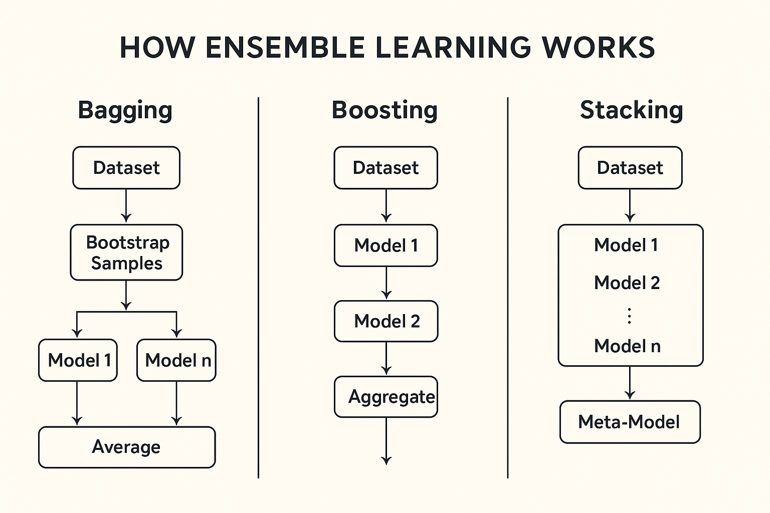

References (APA 7th Edition)
Biau, G., & Scornet, E. (2016). A random forest guided tour. Test, 25(2), 197–227. https://doi.org/10.1007/s11749-016-0481-7
Breiman, L. (1996). Bagging predictors. Machine Learning, 24(2), 123–140. https://doi.org/10.1007/BF00058655
Breiman, L. (2001). Random forests. Machine Learning, 45(1), 5–32. https://doi.org/10.1023/A:1010933404324
Chen, T., & Guestrin, C. (2016). XGBoost: A scalable tree boosting system. In Proceedings of the 22nd ACM SIGKDD International Conference on Knowledge Discovery and Data Mining (pp. 785–794). https://doi.org/10.1145/2939672.2939785
Dietterich, T. G. (2000). Ensemble methods in machine learning. In Multiple Classifier Systems (pp. 1–15). Springer. https://doi.org/10.1007/3-540-45014-9_1
Freund, Y., & Schapire, R. E. (1997). A decision-theoretic generalization of on-line learning and an application to boosting. Journal of Computer and System Sciences, 55(1), 119–139. https://doi.org/10.1006/jcss.1997.1504
Kuhn, M., & Johnson, K. (2013). Applied predictive modeling. Springer. https://doi.org/10.1007/978-1-4614-6849-3
Wolpert, D. H. (1992). Stacked generalization. Neural Networks, 5(2), 241–259. https://doi.org/10.1016/S0893-6080(05)80023-1
Zhang, C., & Ma, Y. (Eds.). (2012). Ensemble machine learning: Methods and applications. Springer. https://doi.org/10.1007/978-1-4419-9326-7
Zhou, Z.-H. (2012). Ensemble methods: Foundations and algorithms. CRC Press.

